Sample Analysing an issue

Let’s analyse an example bug reported by SpotBugs. SpotBugs always gives us a short description of the bugs it detected, for example:
Bug: Call to Person.equals(Integer) in Person.addFriend(Person)
This method calls equals(Object) on two references of different class types and analysis suggests they will be two objects of different classes at runtime. Further, examination of the equals methods that would be invoked suggest that either this call will always return false, or else the equals method is not be symmetric (which is a property required by the contract for equals in class Object).

Double-clicking on the bug description takes us to the location the bug was found in the code, in this case:
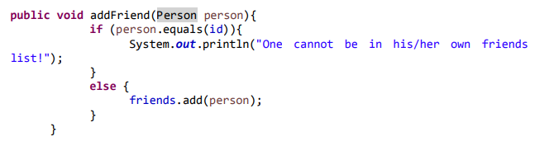
When analysing an issue reported by SpotBugs, the most important thing is to figure out whether an actual fault or a false positive was found. In our case SpotBugs seems to be correct, since the method is trying to compare an integer value to an object from the class Person. Nevertheless, there is a chance the equals() method has been overridden in the class Person and the comparison might therefore be the intended implementation.
Let us examine two possible implementations of the Person class:
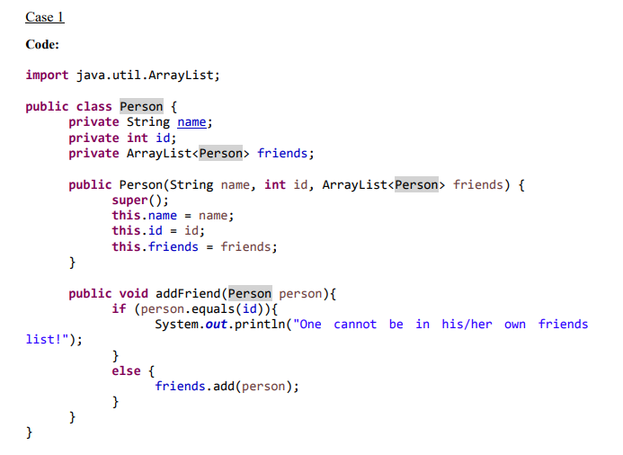
Conclusion:
Since the equals() method is not overridden in this class, it is used incorrectly in the addFriend() method and therefore SpotBugs detected an actual fault.

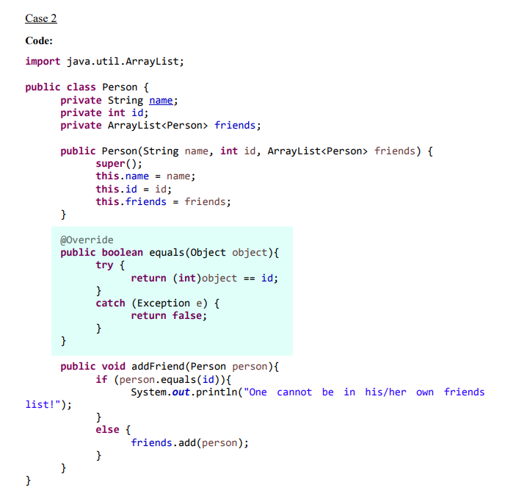

Conclusion:
Even though this code is breaking some Java coding conventions, the equals() method is overridden in a way that it accepts integer values as arguments and compares them to the person’s id. This suggests that the line reported by SpotBugs was an intended implementation and the bug therefore a false positive. Nevertheless, for understandability and scalability reasons the equals() method should be fixed to match the default coding conventions.

